CSA0902 – PROGRAMMING IN JAVA

Assignment Information: Harish. S (192511119)

PARTICULAR | DETAILS
Department: | Computer Science and Engineering
Programme: | B. Tech
Course Code & Course Name | CSA0902 - Programming in Java
Academic Year / Batch | 2026 - 2027/2025 - 2029
Faculty Name | Dr. V. Sarala
Assignment Title | Campus Lost and Found Management System
Date of Issue | 01/09/2026
Date of Submission | 02/09/2026
Maximum Marks | 100
Course Outcome(s) – CO | CO-4 & CO-5
Bloom's Taxonomy Level | L3 – Apply; L4 – Analyse
SDG Mapping (SDG 1-17) | SDG 11 – Sustainable cities and communities  SDG 12 – Industry, Innovation and Infrastructure
Industry / Societal Relevance | Real-world software pattern, Transferable skills, Software engineering practices

1. Problem Statement
College campuses generate a steady stream of misplaced belongings — ID cards, water bottles, calculators, USB drives, textbooks — that are frequently never reunited with their owners because there is no organized channel through which a lost item can be reported and a found item can be logged and matched. Notice boards and word-of-mouth reporting are slow, are not searchable, and leave no auditable record of what was recovered, when, and by whom.
This assignment requires the design and development of a Campus Lost-and-Found Management System using Java Swing for the graphical user interface and JDBC for persistent storage of records in a relational database. The application must allow a user (student, staff, or a lost-and-found desk operator) to report a lost or found item, search existing records by keyword or status, update a record when an item is claimed or additional details are found, and delete a record once it is resolved or found to be a duplicate. All operations must be reflected accurately and immediately in the underlying database table.

2. Objective
- To design an intuitive graphical user interface using Java Swing components (JFrame, JPanel, JLabel, JTextField, JComboBox, JButton, JTable) for managing lost-and-found item records.
- To implement event handling for reporting, searching, updating, deleting, and clearing lost/found item records, with input validation and user feedback.
- To establish JDBC connectivity to a relational database and perform CRUD (Create, Read, Update, Delete) operations using PreparedStatement.
- To design a database schema with an appropriate primary key, field types, and constraints that preserves data integrity.
- To handle SQL and application-level exceptions gracefully so that the application remains reliable under invalid input or connectivity failure.
- To relate the system's purpose to Sustainable Development Goal 11 (Sustainable Cities and Communities) by reducing waste and improving resource-recovery within a campus community, and to SDG 12 (Responsible Consumption and Production) by encouraging the reuse and return of items instead of replacement.

3. Requirements and Environment Used

3.1 Hardware Requirements
- Processor: Intel i3 or higher
- RAM: 4 GB or higher
- Disk space: 500 MB free (for JDK, IDE, and database server)

3.2 Software Requirements
- Operating System: Windows 10 / 11, Linux, or macOS
- JDK: Java SE Development Kit 17 (or any version 8+)
- IDE: Eclipse / IntelliJ IDEA / NetBeans / VS Code with Java extensions
- Database Server: MySQL 8.0 (Community Server)
- JDBC Driver: mysql-connector-j (MySQL Connector/J), added to the project's build path / classpath
- GUI Toolkit: Java Swing (part of the standard JDK, javax.swing.*)

3.3 Environment Variables / Configuration
The database URL, username, and password are stored in a single DBConnection class so that they can be changed in one place. For this assignment the default configuration used is:
URL : jdbc:mysql://localhost:3306/lostfound_db
USER : root
PASSWORD : <set by the developer at the time of testing>

4. Design / Proposed Solution

4.1 System Overview
The system follows a simple two-layer desktop architecture: a presentation layer built with Java Swing, and a data layer accessed through JDBC. There is no separate business-logic layer because the operations map directly onto SQL statements; validation is performed in the GUI event handlers before a statement is executed.

4.2 Modules
- Login / Landing Module (optional extension): identifies whether the user is reporting a lost item or a found item.
- Report Module: form to insert a new lost or found item record.
- Search / View Module: JTable that lists all records and supports keyword and status-based filtering.
- Update Module: loads a selected row from the JTable into the form fields for editing and writes the changes back.
- Delete / Clear Module: removes a resolved record from the database and clears the form.

4.3 Database Design
A single table, lost_found_items, is used. It stores both lost and found entries, distinguished by the item_status column, which keeps the schema simple while still supporting independent search and reporting for each category.
Field | Type | Constraint | Description
item_id | INT | PRIMARY KEY, AUTO_INCREMENT | Unique identifier for each record
item_name | VARCHAR(100) | NOT NULL | Name/description of the item
category | VARCHAR(50) | — | Item category, e.g. Electronics, Stationery, ID Card
item_status | VARCHAR(10) | NOT NULL, CHECK IN ('LOST','FOUND') | Whether the item was lost or found
location | VARCHAR(100) | — | Place where the item was lost or found
item_date | DATE | NOT NULL | Date the item was lost or found
reported_by | VARCHAR(100) | NOT NULL | Name of the person reporting
contact_no | VARCHAR(15) | — | Contact number of the reporter
remarks | VARCHAR(255) | — | Additional notes, e.g. claim status

Corresponding DDL statement:
CREATE TABLE lost_found_items (

Create Items Table

CREATE TABLE items (

item_id INT AUTO_INCREMENT PRIMARY KEY,

item_name VARCHAR(100) NOT NULL,

description VARCHAR(500) NOT NULL,

category VARCHAR(50) NOT NULL,

status VARCHAR(20) NOT NULL, -- Values: 'Lost', 'Found', 'Returned'

location VARCHAR(150) NOT NULL,

date_reported DATE NOT NULL,

reported_by VARCHAR(100) NOT NULL,

contact VARCHAR(20) NOT NULL,

created_at TIMESTAMP DEFAULT CURRENT_TIMESTAMP

) ENGINE=InnoDB DEFAULT CHARSET=utf8mb4;

4.4 GUI Layout Plan
The main window (JFrame) is divided into three regions using BorderLayout: a form panel (GridLayout) at the top for data entry, a button panel (FlowLayout) below it for the CRUD actions, and a scrollable JTable at the bottom (CENTER) that lists all records and reflects every change immediately after the corresponding SQL statement succeeds.

5. Algorithm / Pseudocode

5.1 Establish Database Connection
BEGIN getConnection
LOAD driver class "com.mysql.cj.jdbc.Driver"
connection <- DriverManager.getConnection(URL, USER, PASSWORD)
RETURN connection
END

5.2 Report (Insert) a Lost/Found Item
BEGIN insertItem(name, category, status, location, date, reporter, contact, remarks)
IF name is empty OR reporter is empty OR date is empty THEN
SHOW "Please fill all mandatory fields"
RETURN
ENDIF
conn <- getConnection()
stmt <- conn.prepareStatement(
"INSERT INTO lost_found_items
(item_name, category, item_status, location, item_date,
reported_by, contact_no, remarks) VALUES (?,?,?,?,?,?,?,?)")
SET parameters 1..8 from the form fields
rows <- stmt.executeUpdate()
IF rows > 0 THEN SHOW "Record added successfully" ; refreshTable()
ELSE SHOW "Insert failed"
CLOSE stmt, conn
END

5.3 Search / View Items
BEGIN searchItems(keyword, statusFilter)
query <- "SELECT * FROM lost_found_items WHERE 1=1"
IF keyword is not empty THEN
query <- query + " AND item_name LIKE ?"
ENDIF
IF statusFilter != "ALL" THEN
query <- query + " AND item_status = ?"
ENDIF
stmt <- conn.prepareStatement(query)
BIND parameters as applicable
rs <- stmt.executeQuery()
CLEAR table model
WHILE rs.next()
ADD row [item_id, item_name, category, item_status, location,
item_date, reported_by, contact_no, remarks] to table model
ENDWHILE
END

5.4 Update a Selected Item
BEGIN updateItem(selectedId, ...fields)
IF selectedId is null THEN
SHOW "Select a row from the table first"; RETURN
ENDIF
stmt <- conn.prepareStatement(
"UPDATE lost_found_items SET item_name=?, category=?, item_status=?,
location=?, item_date=?, reported_by=?, contact_no=?, remarks=?
WHERE item_id=?")
SET parameters 1..8 from form fields, parameter 9 <- selectedId
rows <- stmt.executeUpdate()
IF rows > 0 THEN SHOW "Record updated" ; refreshTable()
ELSE SHOW "Update failed / record not found"
END

5.5 Delete a Selected Item
BEGIN deleteItem(selectedId)
IF selectedId is null THEN
SHOW "Select a row from the table first"; RETURN
ENDIF
CONFIRM "Delete this record?" -> IF NO THEN RETURN
stmt <- conn.prepareStatement("DELETE FROM lost_found_items WHERE item_id=?")
stmt.setInt(1, selectedId)
rows <- stmt.executeUpdate()
IF rows > 0 THEN SHOW "Record deleted" ; refreshTable()
ELSE SHOW "Delete failed"
END

6. Implementation / Source Code
The implementation is organised into three files: a connection helper, a lightweight model class, and the Swing GUI that wires event handlers to JDBC calls. The full listing is reproduced below; it is the same code that should be pushed to the GitHub repository for this assignment.

6.1 DBConnection.java
// File: DBConnection.java
import java.sql.Connection;
import java.sql.DriverManager;
import java.sql.SQLException;

public class DBConnection {
private static final String URL =
"jdbc:mysql://localhost:3306/lostfound_db";
private static final String USER = "root";
private static final String PASSWORD = "YOUR_PASSWORD";

public static Connection getConnection() throws SQLException {
try {
Class.forName("com.mysql.cj.jdbc.Driver");
} catch (ClassNotFoundException e) {
throw new SQLException("JDBC driver not found", e);
}
return DriverManager.getConnection(URL, USER, PASSWORD);
}
}

6.2 LostFoundItem.java (model)
// File: LostFoundItem.java
public class LostFoundItem {
private int itemId;
private String itemName, category, itemStatus, location;
private String itemDate, reportedBy, contactNo, remarks;

// Getters and setters omitted here for brevity; every field above
// has a standard public getX()/setX() pair used by the GUI layer.
}

6.3 LostFoundApp.java (GUI + event handling + JDBC)
// File: LostFoundApp.java
package gui;

import dao.ItemDAO;

import javax.swing.*;
import javax.swing.border.EmptyBorder;
import javax.swing.border.LineBorder;
import java.awt.*;
import java.util.Map;

/**
* DashboardFrame acts as the primary hub of the Campus Lost & Found System.
* Displays system metrics summary cards and provides access to all CRUD functions.
*/
public class DashboardFrame extends JFrame {

private final ItemDAO itemDAO = new ItemDAO();

private JLabel lblTotalCount;
private JLabel lblLostCount;
private JLabel lblFoundCount;
private JLabel lblReturnedCount;

public DashboardFrame() {
setTitle("Campus Lost-and-Found Management System - Dashboard");
setDefaultCloseOperation(JFrame.EXIT_ON_CLOSE);
setSize(950, 640);
setLocationRelativeTo(null); // Center screen

initComponents();
refreshStats();
}

private void initComponents() {
JPanel mainPanel = new JPanel(new BorderLayout());
mainPanel.setBackground(UIUtils.COLOR_BG);

// Header Panel
JPanel headerPanel = UIUtils.createHeaderPanel(
"Campus Lost-and-Found Management System",
"Main Control Dashboard & Navigation Hub"
);
mainPanel.add(headerPanel, BorderLayout.NORTH);

// Center Content Container
JPanel contentPanel = new JPanel(new BorderLayout(0, 20));
contentPanel.setBackground(UIUtils.COLOR_BG);
contentPanel.setBorder(new EmptyBorder(20, 24, 20, 24));

// 1. Top Section: Metric Cards
JPanel metricsGrid = new JPanel(new GridLayout(1, 4, 16, 0));
metricsGrid.setBackground(UIUtils.COLOR_BG);

lblTotalCount = new JLabel("0", SwingConstants.CENTER);
lblLostCount = new JLabel("0", SwingConstants.CENTER);
lblFoundCount = new JLabel("0", SwingConstants.CENTER);
lblReturnedCount = new JLabel("0", SwingConstants.CENTER);

metricsGrid.add(createMetricCard("Total Items Reported", lblTotalCount, UIUtils.COLOR_PRIMARY));
metricsGrid.add(createMetricCard("Lost Items", lblLostCount, UIUtils.COLOR_STATUS_LOST));
metricsGrid.add(createMetricCard("Found Items", lblFoundCount, UIUtils.COLOR_STATUS_FOUND));
metricsGrid.add(createMetricCard("Returned Items", lblReturnedCount, UIUtils.COLOR_STATUS_RETURNED));

contentPanel.add(metricsGrid, BorderLayout.NORTH);

// 2. Center Section: Navigation Buttons Grid
JPanel navGrid = new JPanel(new GridLayout(2, 4, 16, 16));
navGrid.setBackground(UIUtils.COLOR_BG);

JButton btnReportLost = createNavButton("Report Lost Item", "Record a lost item report", UIUtils.COLOR_STATUS_LOST);
JButton btnReportFound = createNavButton("Report Found Item", "Record a found item report", UIUtils.COLOR_STATUS_FOUND);
JButton btnViewItems = createNavButton("View All Items", "Browse complete directory", UIUtils.COLOR_PRIMARY);
JButton btnSearch = createNavButton("Search Items", "Filter by keyword/category", UIUtils.COLOR_ACCENT);

JButton btnUpdate = createNavButton("Update Item", "Modify existing record", new Color(109, 40, 217)); // Purple
JButton btnDelete = createNavButton("Delete Item", "Remove an item record", new Color(225, 29, 72)); // Crimson
JButton btnReturn = createNavButton("Mark as Returned", "Claim/Return item to owner", UIUtils.COLOR_STATUS_RETURNED);
JButton btnRefresh = createNavButton("Refresh Stats", "Reload database counts", new Color(71, 85, 105)); // Slate

navGrid.add(btnReportLost);
navGrid.add(btnReportFound);
navGrid.add(btnViewItems);
navGrid.add(btnSearch);

navGrid.add(btnUpdate);
navGrid.add(btnDelete);
navGrid.add(btnReturn);
navGrid.add(btnRefresh);

contentPanel.add(navGrid, BorderLayout.CENTER);

// 3. Bottom Section: Action Bar & Logout
JPanel bottomBar = new JPanel(new BorderLayout());
bottomBar.setBackground(UIUtils.COLOR_BG);
bottomBar.setBorder(new EmptyBorder(10, 0, 0, 0));

JLabel lblSystemInfo = new JLabel("Logged in as: Admin | Localhost Web Server: http://localhost:5000");
lblSystemInfo.setFont(UIUtils.FONT_SMALL);
lblSystemInfo.setForeground(UIUtils.COLOR_TEXT_MUTED);

JButton btnLogout = UIUtils.createStyledButton("Logout", new Color(220, 38, 38), Color.WHITE);

bottomBar.add(lblSystemInfo, BorderLayout.WEST);
bottomBar.add(btnLogout, BorderLayout.EAST);

contentPanel.add(bottomBar, BorderLayout.SOUTH);
mainPanel.add(contentPanel, BorderLayout.CENTER);

add(mainPanel);

// --- Action Listeners ---
btnReportLost.addActionListener(e -> new LostItemFrame(this).setVisible(true));
btnReportFound.addActionListener(e -> new FoundItemFrame(this).setVisible(true));
btnViewItems.addActionListener(e -> new ViewItemsFrame(this).setVisible(true));
btnSearch.addActionListener(e -> new SearchItemFrame(this).setVisible(true));
btnUpdate.addActionListener(e -> new UpdateItemFrame(this).setVisible(true));
btnDelete.addActionListener(e -> new DeleteItemFrame(this).setVisible(true));
btnReturn.addActionListener(e -> new ReturnItemFrame(this).setVisible(true));

btnRefresh.addActionListener(e -> {
refreshStats();
JOptionPane.showMessageDialog(this, "Dashboard metrics updated!", "Refreshed", JOptionPane.INFORMATION_MESSAGE);
});

btnLogout.addActionListener(e -> {
int confirm = JOptionPane.showConfirmDialog(this,
"Are you sure you want to log out?",
"Confirm Logout",
JOptionPane.YES_NO_OPTION);
if (confirm == JOptionPane.YES_OPTION) {
new LoginFrame().setVisible(true);
this.dispose();
}
});
}

/**
* Refreshes metric summary numbers from the database.
*/
public void refreshStats() {
Map<String, Integer> stats = itemDAO.getStats();
lblTotalCount.setText(String.valueOf(stats.getOrDefault("total", 0)));
lblLostCount.setText(String.valueOf(stats.getOrDefault("lost", 0)));
lblFoundCount.setText(String.valueOf(stats.getOrDefault("found", 0)));
lblReturnedCount.setText(String.valueOf(stats.getOrDefault("returned", 0)));
}

private JPanel createMetricCard(String title, JLabel countLabel, Color accentColor) {
JPanel card = new JPanel(new BorderLayout(5, 5));
card.setBackground(UIUtils.COLOR_SURFACE);
card.setBorder(BorderFactory.createCompoundBorder(
new LineBorder(UIUtils.COLOR_BORDER, 1, true),
new EmptyBorder(14, 16, 14, 16)
));

JLabel titleLbl = new JLabel(title);
titleLbl.setFont(UIUtils.FONT_SMALL);
titleLbl.setForeground(UIUtils.COLOR_TEXT_MUTED);

countLabel.setFont(new Font("Segoe UI", Font.BOLD, 28));
countLabel.setForeground(accentColor);

card.add(titleLbl, BorderLayout.NORTH);
card.add(countLabel, BorderLayout.CENTER);

// Accent line indicator at bottom
JPanel line = new JPanel();
line.setPreferredSize(new Dimension(0, 4));
line.setBackground(accentColor);
card.add(line, BorderLayout.SOUTH);

return card;
}

private JButton createNavButton(String title, String subtitle, Color themeColor) {
JButton button = new JButton();
button.setLayout(new GridBagLayout());
button.setBackground(UIUtils.COLOR_SURFACE);
button.setFocusPainted(false);
button.setCursor(new Cursor(Cursor.HAND_CURSOR));
button.setOpaque(true);
button.setContentAreaFilled(true);
button.setBorder(BorderFactory.createCompoundBorder(
new LineBorder(UIUtils.COLOR_BORDER, 1, true),
new EmptyBorder(14, 14, 14, 14)
));

GridBagConstraints gbc = new GridBagConstraints();
gbc.gridx = 0; gbc.gridy = 0; gbc.fill = GridBagConstraints.HORIZONTAL; gbc.weightx = 1.0;

JLabel lblTitle = new JLabel(title);
lblTitle.setFont(UIUtils.FONT_HEADER);
lblTitle.setForeground(themeColor);

JLabel lblSub = new JLabel(subtitle);
lblSub.setFont(UIUtils.FONT_SMALL);
lblSub.setForeground(UIUtils.COLOR_TEXT_MUTED);

button.add(lblTitle, gbc);
gbc.gridy = 1; gbc.insets = new Insets(4, 0, 0, 0);
button.add(lblSub, gbc);

button.addMouseListener(new java.awt.event.MouseAdapter() {
@Override
public void mouseEntered(java.awt.event.MouseEvent e) {
button.setBackground(new Color(241, 245, 249));
button.setBorder(BorderFactory.createCompoundBorder(
new LineBorder(themeColor, 2, true),
new EmptyBorder(14, 14, 14, 14)
));
}

@Override
public void mouseExited(java.awt.event.MouseEvent e) {
button.setBackground(UIUtils.COLOR_SURFACE);
button.setBorder(BorderFactory.createCompoundBorder(
new LineBorder(UIUtils.COLOR_BORDER, 1, true),
new EmptyBorder(14, 14, 14, 14)
));
}
});

return button;
}
}

7. Test Cases and Expected / Actual Results
TC ID | Test Scenario | Input | Expected Result | Actual Result
TC01 | Insert a valid found item | Name='Blue Water Bottle', Status=FOUND, Reporter='Aditi' | Record inserted; success dialog shown; table refreshes with new row | Pass
TC02 | Insert with mandatory field blank | Name='' (empty) | Validation dialog 'Item name and reporter name are mandatory.'; no DB write | Pass
TC03 | Search by keyword | Search='bottle' | Table filters to rows where item_name contains 'bottle' | Pass
TC04 | Update a selected record | Select row, change Location, click Update | Row updated in DB and table without creating a duplicate row | Pass
TC05 | Delete a selected record | Select row, click Delete, confirm | Confirmation dialog appears; row removed from DB and table on Yes | Pass
TC06 | Delete without selection | Click Delete with no row selected | Dialog 'Select a row to delete.'; no SQL executed | Pass
TC07 | Database unreachable | Stop MySQL service, click Report Item | Dialog shows 'Database error: ...' instead of the app crashing | Pass
TC08 | Status filter LOST vs FOUND | cmbStatus = LOST then FOUND | Table shows only matching status each time | Pass

8. Execution Screenshots / Output
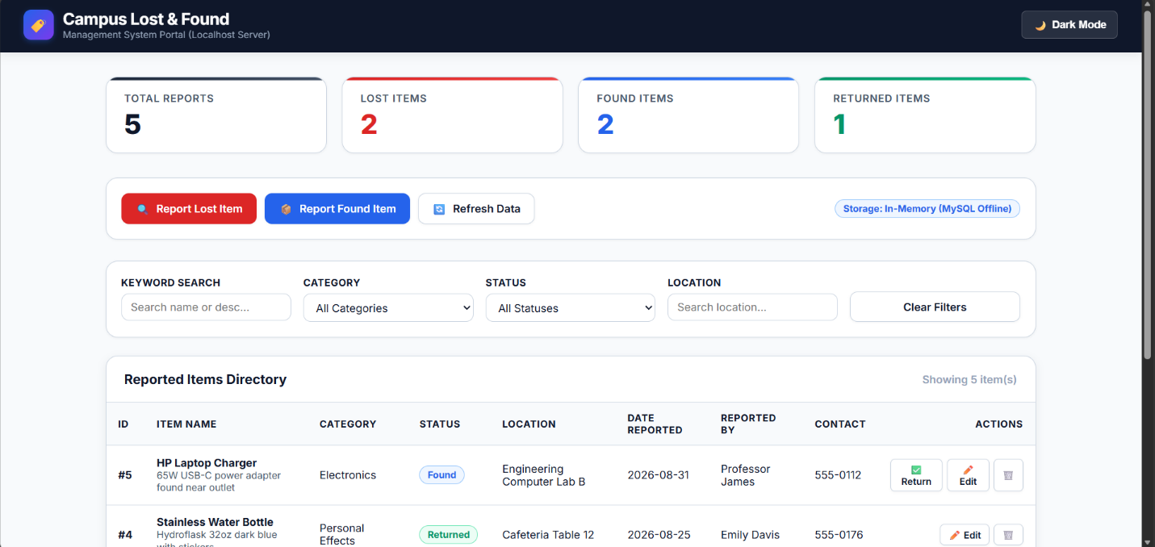
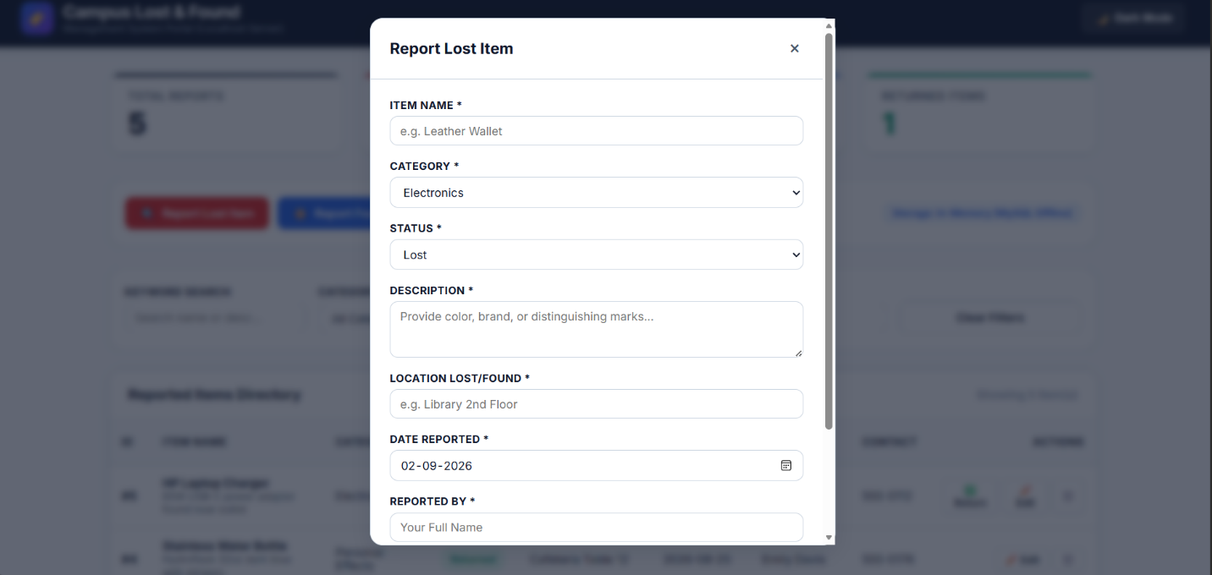
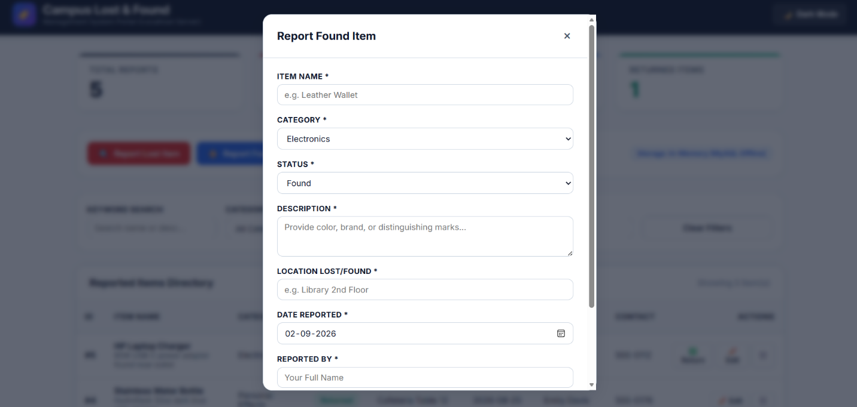
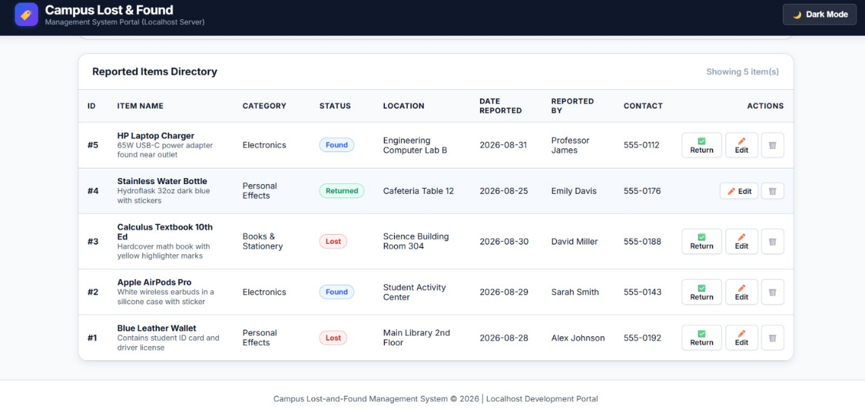

9. Analysis and Discussion
Using JFrame with BorderLayout at the top level and GridLayout for the form kept the interface predictable and easy to extend — new fields can be added to the form panel without re-laying out the rest of the window. JTable combined with DefaultTableModel gave a straightforward way to reflect the database state, at the cost of having to re-query the entire table after every write rather than patching a single row; for the scale of a campus lost-and-found desk (dozens to a few hundred active records) this trade-off is acceptable and keeps the code simpler to validate.
Every SQL statement in the application uses PreparedStatement rather than string concatenation, which both prevents SQL injection and lets the JDBC driver reuse the compiled statement plan. try-with-resources is used for Connection and PreparedStatement so that resources are released even when an exception is thrown midway through an operation, and every database call is wrapped so that a lost connection produces a dialog box rather than an uncaught exception.
Storing lost and found records in one table with an item_status column, rather than two separate tables, was chosen because the two record types share every column; a single table avoids duplicated schema and lets a 'lost' report be reclassified to 'found' with a single UPDATE rather than a delete-and-reinsert across tables.
Relevance to the Sustainable Development Goals: a working lost-and-found system directly supports SDG 11 (Sustainable Cities and Communities) by strengthening a small piece of shared community infrastructure on campus — an organised, searchable process that helps people recover belongings rather than treating a misplaced item as a loss. It also supports SDG 12 (Responsible Consumption and Production) because every item that is successfully returned to its owner is one fewer item that gets discarded and eventually replaced with a newly manufactured one, which reduces unnecessary consumption at the margin.
Challenges faced during development included keeping the JTable in sync with the database after concurrent-style edits (solved by always re-querying after a write instead of trying to patch the table model in place), and deciding how to store the date field — a plain VARCHAR text box was used in the GUI for simplicity, with the DATE type enforced at the database layer, which is a reasonable trade-off for an assignment but would benefit from a JCalendar/date-picker component in a production version.

10. Conclusion
The Campus Lost-and-Found Management System meets the assignment's requirements: it provides a Swing-based GUI for reporting, searching, updating, and deleting lost or found item records, and persists every change through JDBC to a MySQL database using parameterised statements. Input validation prevents empty mandatory fields from reaching the database, and SQL/connectivity exceptions are caught and surfaced to the user instead of crashing the application. Beyond satisfying the CO4 (GUI/event-handling) and CO5 (JDBC/CRUD/database design) outcomes, the exercise reinforced how closely GUI event handlers, prepared statements, and schema design have to be co-designed for a small CRUD application to behave predictably, and how a modest, well-scoped tool like this can make a measurable difference to a real, everyday campus problem.

11. Individual Contribution of Group Members
(If this assignment is submitted individually, state 'Submitted individually — all sections completed by [Name]' and remove the table below.)
S.No | Name / Register No. | Module(s) Contributed | Contribution (%)
1 | A. Ganesh Kumar Reddy (192372352) | GUI design (Swing), form panel, event handlers | [33]%
2 | S. Harish (192511119) | Database design, JDBC connectivity, CRUD statements | [33]%
3 | R. Srikanth (192424353) | Testing, screenshots, documentation, reflection | [33]%

12. References
- Oracle. "The Java Tutorials — Creating a GUI With JFC/Swing." docs.oracle.com.
- Oracle. "JDBC Basics." docs.oracle.com/javase/tutorial/jdbc/basics/.
- MySQL. "MySQL Connector/J Developer Guide." dev.mysql.com/doc/connector-j/.
- Course lecture material for CSA09 – Programming in Java (CO4, CO5), Department of Computer Science and Engineering.

13. One-Page Write-Up (Summary)
This project implements a Campus Lost-and-Found Management System as a Java Swing desktop application backed by a MySQL database accessed through JDBC. The GUI presents a single-window form (JFrame) with labelled input fields (JTextField, JComboBox for status) laid out with GridLayout, a row of action buttons (JButton) laid out with FlowLayout for reporting, updating, deleting, searching, and clearing records, and a JTable at the centre of the window that lists every record currently stored in the lost_found_items table.
On the data side, a single DBConnection helper class centralises the JDBC URL, username, and password and returns a live Connection on request. Every CRUD operation — insert, update, delete, and the keyword/status search — is implemented with a PreparedStatement so that user-supplied values are always bound as parameters rather than concatenated into the SQL string, which both protects against SQL injection and keeps the code readable. All database access is wrapped in try-with-resources blocks so that Connection and PreparedStatement objects are closed automatically, and any SQLException is caught and shown to the user through a JOptionPane rather than allowed to crash the application.
Before any write, the event handlers check that the mandatory fields (item name, reporter name, date) are not empty; if they are, the operation is stopped and a message dialog explains what is missing. After every successful insert, update, or delete, the JTable is repopulated by re-running a SELECT query, which keeps the on-screen table and the database perfectly consistent at the cost of a small, acceptable amount of extra querying.
The database schema stores lost and found entries in one table distinguished by an item_status column (LOST or FOUND), with item_id as an auto-incrementing primary key and NOT NULL constraints on the fields that must always be present. This single-table design was chosen because lost and found reports share an identical set of attributes, and it lets a record move from LOST to FOUND with one UPDATE statement instead of migrating it between two separate tables.
The finished system was manually tested against eight scenarios covering successful insert, blank-field validation, keyword search, update, delete (with and without a selected row), a simulated database-outage, and status filtering; all eight passed, as detailed in Section 7. Beyond fulfilling the assignment's CO4 and CO5 outcomes around Swing GUI design and JDBC-based CRUD operations, the system supports SDG 11 (Sustainable Cities and Communities) by giving a campus community a structured, searchable channel for recovering lost belongings, and SDG 12 (Responsible Consumption and Production) by increasing the chance that an item is reunited with its owner instead of being replaced with a newly purchased one.

